**ASSIGHNMENT OF PHP: Regular Expression**

**1.create a form, do the validation with the help of jquery and regular expression.**

**ANSWER 1:**

**i>Username should only start with letter A,P,Q,Z and end with Biya,We,Jzz**

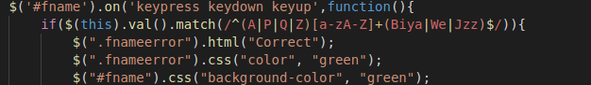

**ii>User the last name should start with Bhfy, W124, Jv.! and end with A, P,Q,Z**

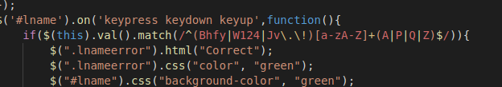

**iii> Contact no should start with 9,6,7,8 and end with 7,3646,976**

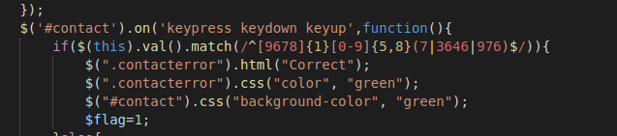

**iv> Email validation should be there with regular expression.**

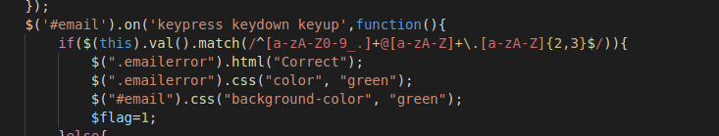

***\*The above exercise will be on HTML and jquery with the proper functioning***

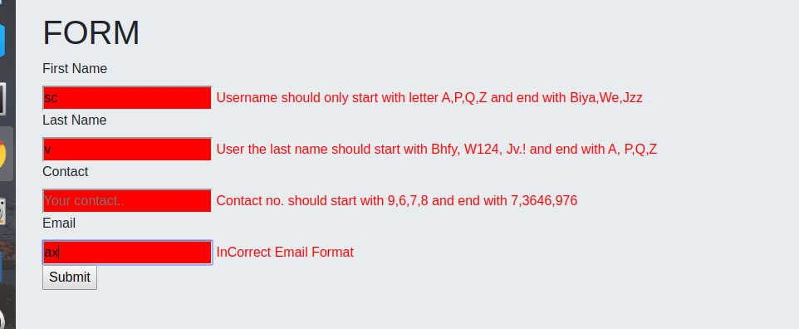

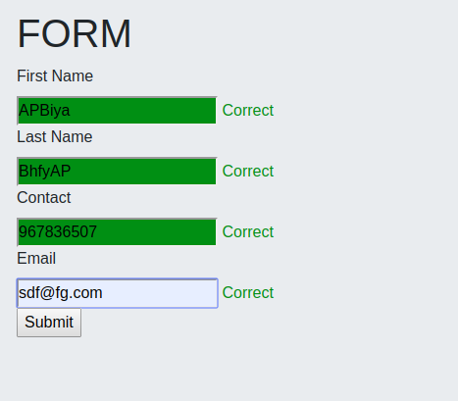

**2. Use XPath to determine/Select At least 10 elements on google chrome from the given HTML:-**

**https://docs.google.com/document/d/14O5UaTngsxnSIbYYVwR3y8THNnGBJXx0y_DtQdivAkU/edit**

**\**do not copy XPath from developer tool use only your understanding to determine Xpath***

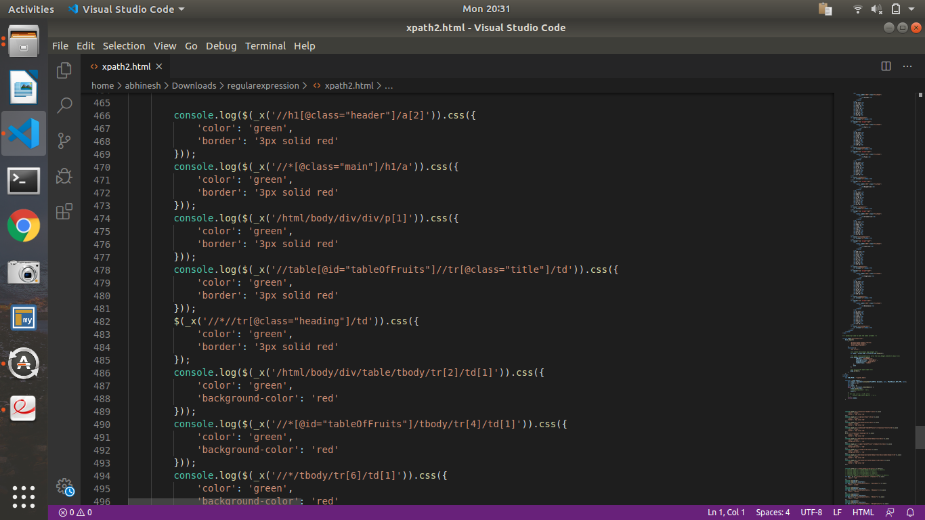

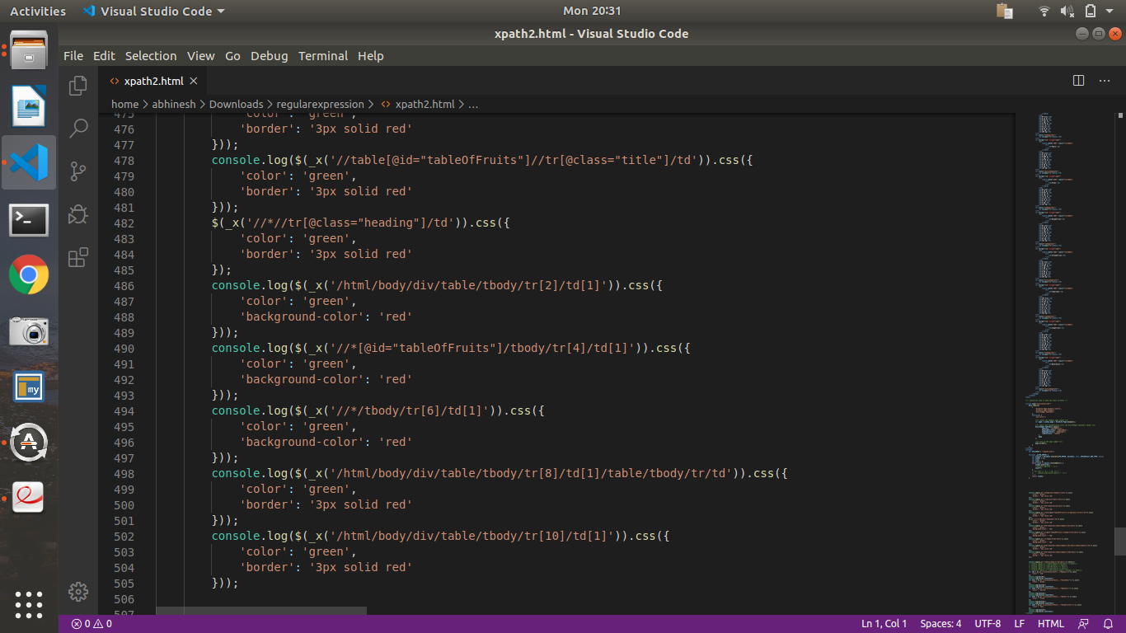

***3.* In the given HTML use text, contains the function of XPATH to determine the value of different 5 fruit names.**

**ANSWER 3:**

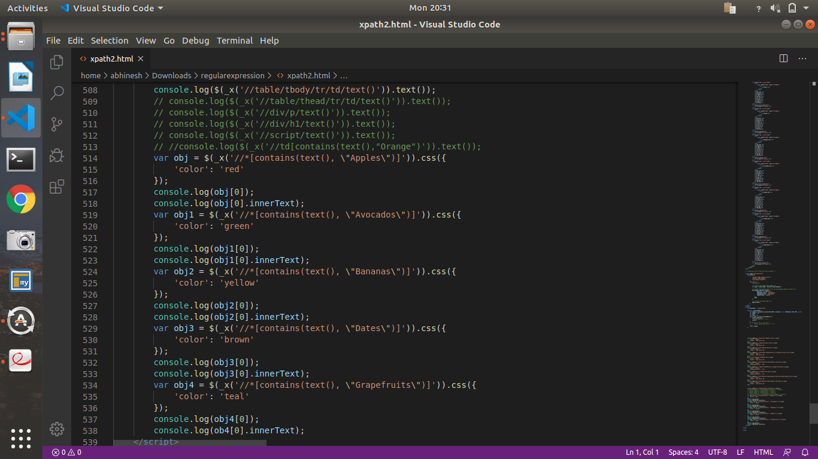

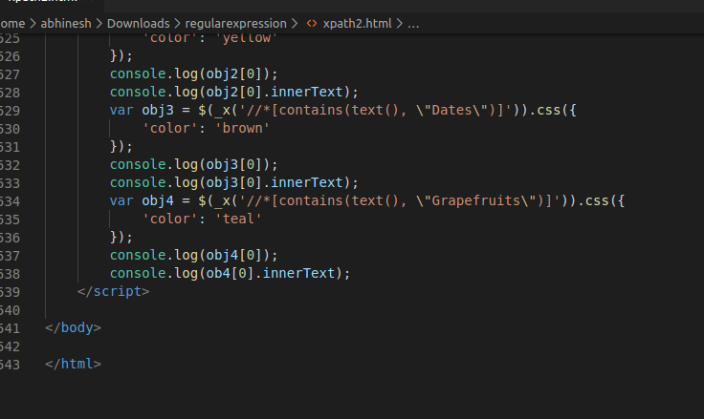

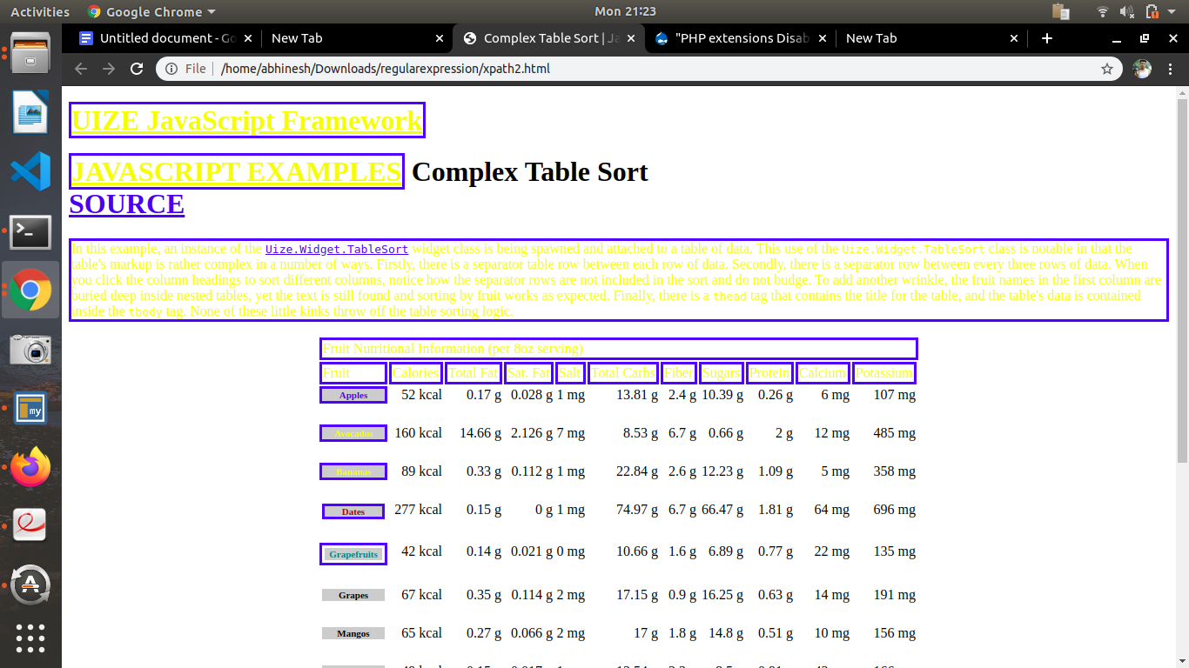

**4.create database according to your understanding with basic profile detail and write queries to fetch all data-name, contact, email, address on the basis of REGULAR EXPRESSION.**

**Answer 4:**

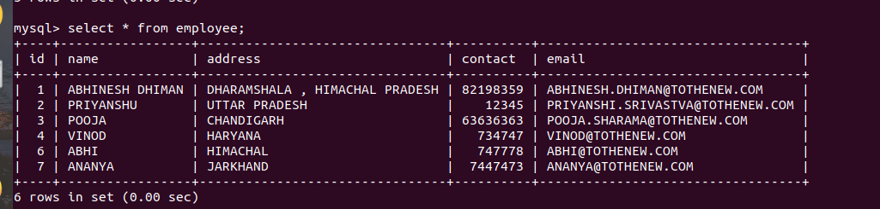

**SELECT name FROM employee WHERE name REGEXP '^A';**

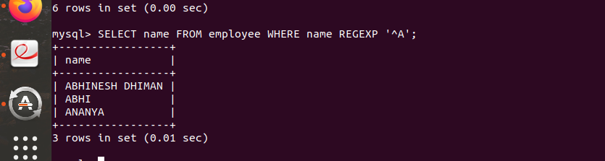

**SELECT name FROM employee WHERE email REGEXP '.com$';**

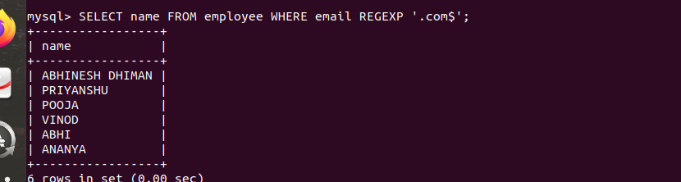

**SELECT name FROM employee WHERE name REGEXP '[AJ]' ;**

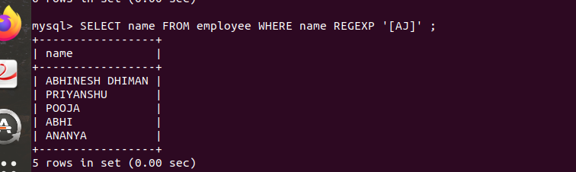

**SELECT * FROM employee WHERE email REGEXP '[H].[COM]' ;**

